

# Introduction to Mechatronics and System Engineering

Marc Budinger

marc.budinger@insa-toulouse.fr

### Objectives and content

Mechatronic and space systems are highly complex systems that often have to meet specific and stringent requirements depending on the application. They require the joint development of technological systems and control software. This course introduces the concepts and development of such systems:

- Requirements analysis and preliminary design

- Dynamic modeling and identification of multiphysics technological systems.

- PID control and digital implementation.

### Case studies

This course will take as case studies the thermal and attitude control of Cubesats. For pedagogical reasons, the approaches will be deliberately simplified, and the digital implementation of the correctors will be done on Arduino boards.

### Program

**Technical requirement definition:**  
- Lecture (1.25 h, Marc BUDINGER, INSA Toulouse): Systems engineering approaches.  
- Lecture (1.25 h, Yann Cervantes, CNES): Satellite thermal control systems.  
- Homework (2.5 h): Reading documents (CubeSat)   
- Lecture (1.25 h, Marc BUDINGER, INSA Toulouse) : System modelling with lumped parameter models (Modelica & Jupyter notebook).  
- Tutorial (2.5h): Cubesat thermal model and power requirements of a thermal control system.

**Control software definition:**- Lecture (1.25 h): Control software development and TCLab Introduction

- Tutorial (2.5h): TClab card, identification step

- Homework (2.5h): Identification of a model (1st, 2nd order) for control

- Tutorial (2.5h): Control and validation by simulation & test (TCLab card + python)

- Homework (2.5h): Control and validation by simulation on linearised model (Cubesat)

- Lab (3.75h): Control prototyping (PID anti-windup) on microcontroller (arduino + TCLab card)

**Examination:**

- Lab (2.5h): Response to a new (thermal) need, examination  
Motivated students can choose to meet an additional need for satelitte attitude control. They are invited to read and prepare the dedicated sections of this course.

## Tools:

* Course website (https://sizinglab.github.io/SystemsEngineeringIntroduction/)
* Course Github repository (https://github.com/SizingLab/SystemsEngineeringIntroduction)
* Python (Jupyter Notebooks)

# Complex technological systems and space systems

## From mechanical systems to complex technological systems

Many mechanical systems have evolved into complex technological systems.

Under each figure, answer the following questions:

* What are their functions, performance and reliability?
* What technical fields are needed to design them?
* Which engineers?

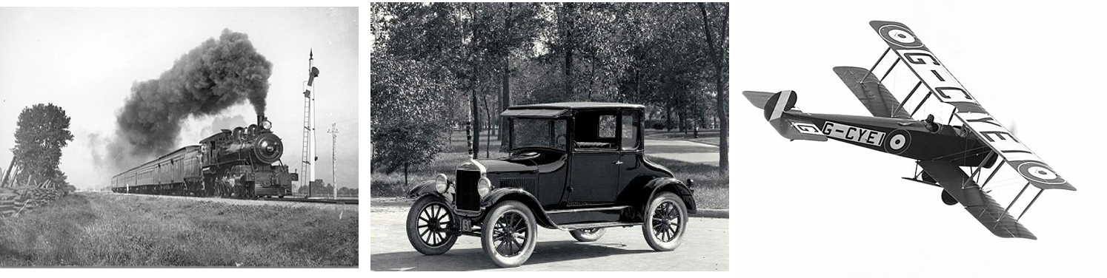

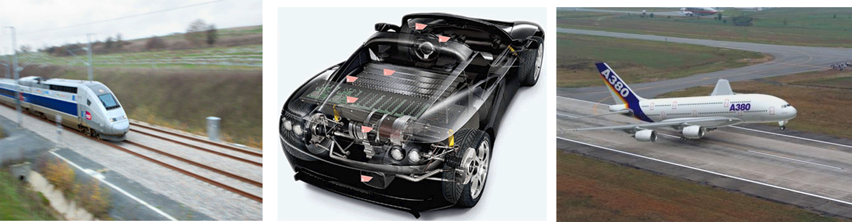

The car is typical of this evolution in technological systems.

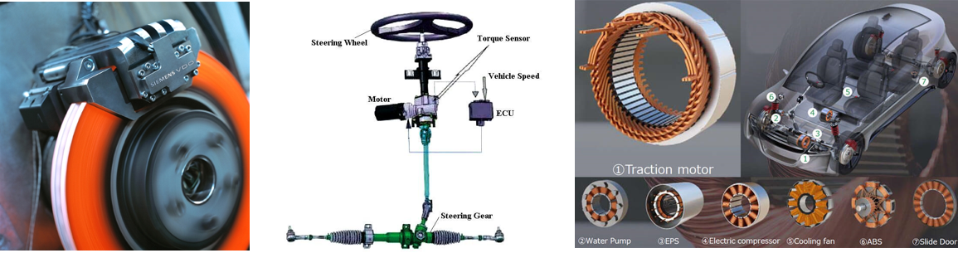

**Electronic and computer technologies** have been integrated into combustion-powered vehicles:

**New architectures** are seeing a multiplication of functions: GPS, Mobile, Multimedia, Active safety (ABS, ESP, lane tracking, ADAS)

**Power electronics, electric motors and electrochemical technologies** are playing an increasingly important role

## System definition

The System Engineering Handbook of NASA define a system [Nasa, 2017] as:

A **“system”** is the *combination of elements* that function together to produce the capability required to *meet a need*. The elements include all *hardware, software*, equipment, facilities, personnel, processes, and procedures needed for this purpose; that is, all things required to produce system-level results. [...] The value added by the system as a whole, beyond that contributed independently by the parts, is primarily created by the *relationship among the parts*; that is, *how they are interconnected*.

The aim of this teaching module is to introduce you to the approaches needed to design a system, particularly with regard to the following aspects:  
-*meet a need*: functional analysis, preliminary design  
-*hardware, software*: mechatronic and electronic technology, programming  
-*how they are interconnected*: architecture, system simulation  
through a **space subsystem**.

## Space systems in New Space

NewSpace refers to the emergence of a private-initiative space industry at the beginning of the 21st century, stimulated by certain governments to strengthen international competitiveness while guaranteeing strategic independence in key sectors.

NewSpace concern in particular a group of relatively new aerospace companies working to develop low-cost, public access to space exploration and space applications:

* **New Launchers:** [Latitude](https://www.latitude.eu) (formerly Venture Orbital Systems) is a French start-up based in Reims. It produces the Zephyr micro-launcher and its Navier 3D-printed engine to provide orbital launch services tailored to nano-satellites.
* **Nanosatellites constellations:** [Kineis](https://www.kineis.com/iot-technologie/) is a French project for a constellation of nano-satellites designed to provide Internet of Things (IoT) services via satellite. The Kineis project is a continuation of the Argos system, which has been in existence since the 1980s. [Hemeria](https://www.hemeria-group.com/wp-content/uploads/2022/05/NANOSAT_FR_2022.pdf) supplies Kineis with the 25 nanosatellites of this 1st European nanosatellite constellation dedicated to the Internet of Things.
* **Ground applications**: [Naïo Technologies](https://www.naio-technologies.com/) is a Toulouse-based start-up specialising in agricultural robotics. The company develops and markets robots for farmers designed to reduce drudgery at work. Robtos are autonomous thanks to RTK GNSS positionning (Real-time kinematic satelite positioning providing up to centimetre-level accuracy).

## Cubesat platform

[Cubesats](https://en.wikipedia.org/wiki/CubeSat) are nanosatellites using standardised formats (1 unit or 1U = 10 cm x 10 cm x 10 cm) and reusable technical subsystem [kits](https://www.cubesatshop.com/) supplied by an ecosystem of companies and start-ups.

The graphic below, called Work Breakdown Structure (WBS), shows how a cubesat satellite programme can be broken down into products of different sizes or levels of complexity Beale, 2006: systems, sub-systems, components, parts.

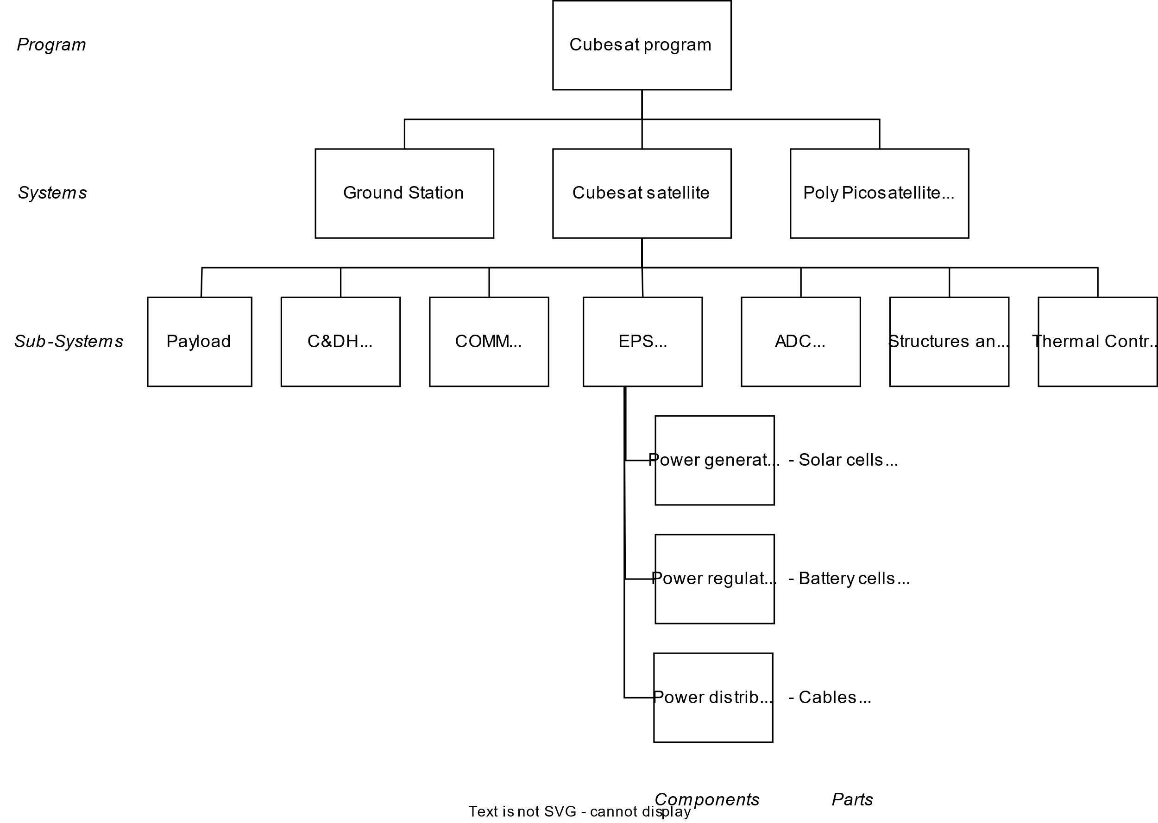

The Product Breakdown Structure (PBS) decomposes the studied system into products and the Work Breakdown Structure (WBS) complete this structure with the tasks [Faure, 2020]:

* Products – Anything that can be built (e.g., structure), created (e.g., software), or bought (e.g., solar cells)
* Tasks – The work (and the workpackages) that need to be executed throughout the project (e.g., manage requirements; perform vibration test; carry out the integration of the payload with the satellite bus)

## Case study

During this teaching module, you will have to put yourself in the role of a start-up wanting to offer kits enabling:

* the **thermal control** of cubesats. Your first products will be for applications requiring heating, such as batteries, liquid propellant tanks, scientific experiments, etc. This type of product contains both hardware (temperature control components) and software (temperature control algorithms).

[*Battery pack of a cubesat*](https://gomspace.com/shop/subsystems/power/nanopower-bpx.aspx) 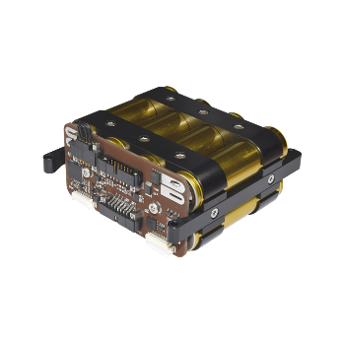

* the **attitude control** of cubesats. Your first products will be a reaction wheel a basic technological building block for controlling the satellite's attitude, which includes both hardware (inertia wheel, brushless motor, power electronics, magnetic sensors) and software (attitude control algorithms).

*Reaction wheels of* [*Comat*](https://comat.space/) 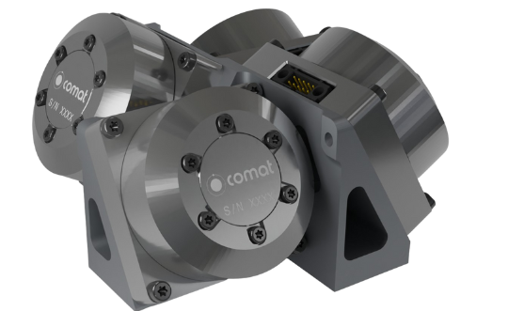

## Homework

* Read these documents: [Les CubeSats en bref](https://www.asc-csa.gc.ca/fra/satellites/cubesat/qu-est-ce-qu-un-cubesat.asp) and [Introduction to CubeSat Technologies](https://www.unoosa.org/documents/pdf/psa/access2space4all/KiboCUBE/AcademySeason2/On-demand_Pre-recorded_Lectures/KiboCUBE_Academy_2021_OPL07.pdf)

## References

[Nasa, 2017a] Hirshorn, S. R., Voss, L. D., & Bromley, L. K. (2017). Nasa systems engineering handbook (No. HQ-E-DAA-TN38707). [Link](https://www.nasa.gov/wp-content/uploads/2018/09/nasa_systems_engineering_handbook_0.pdf)

[Nasa, 2017b] Jamie, C., Roland, C., Justin, F., & Alicia, J. (2017). Basic concepts and processes for first-time CubeSat developers. CubeSat101, CaliforDesign of a CubeSat Testbednia. [Link](https://www.nasa.gov/wp-content/uploads/2017/03/nasa_csli_cubesat_101_508.pdf)

[Beale, 2006] Beale, D., & Bonometti, J. (2006). Systems engineering (SE)-the systems design process. The Lunar Engineering Handbook, Auburg University, Auburn. [Link](https://www.eng.auburn.edu/~dbeale/ESMDCourse/Chapter3.htm)

[Faure, 2020] Faure, P., (2020). SmallSats and Systems Engineering, California Polytechnic State University.[Link](https://www.nasa.gov/wp-content/uploads/2020/06/s3vi_smallsats_and_se_pf_200715_0.pdf)

# System engineering

Figure below illustrates the complete lifecycle of a complex technological system. Differents standards define the interdisciplinary tasks required to transform needs, requirements and constraints encountered. We will focus in this lecture on the first step: the system definition.

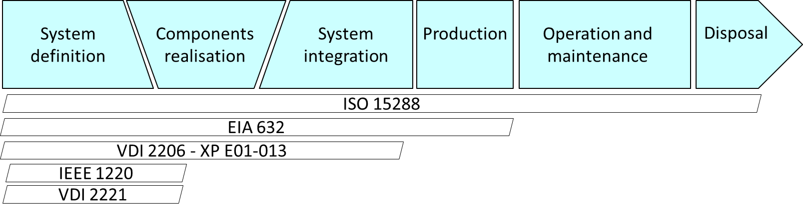

## System design process

The NASA System Engineering Handbook [NASA, 2017] distingues four system design processes enabling the system definition: developing stakeholder expectations, technical requirements, logical decompositions, and design solutions. These system design processes are interdependent, highly iterative and recursive processes resulting on the different systems, subsystems in a validated set of requirements and a design solution that satisfies a set of stakeholder expectations.

*System design process:* 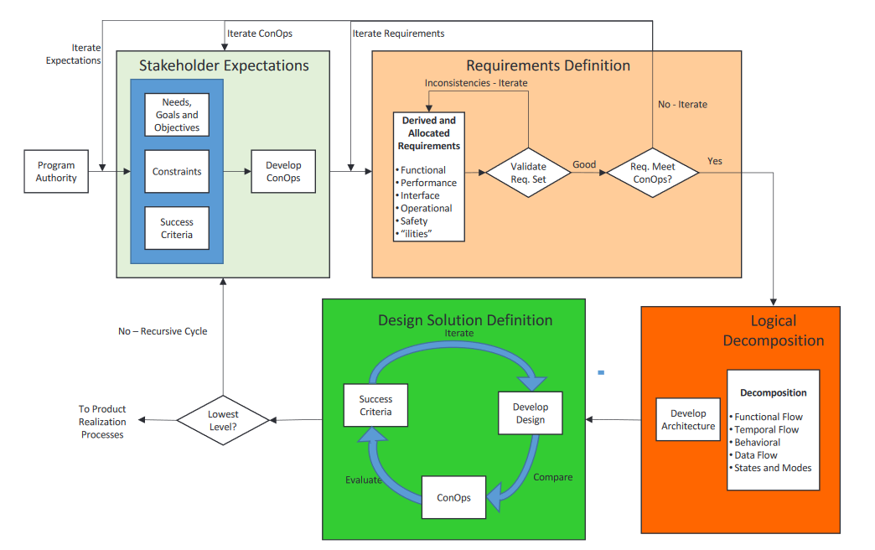

Graphical representation tools can be uses for theses processes:

* Those of the APTE method [Audry, 2010] derived from value analysis applied to the redesign of technical systems.
* The SYSML language [Le Gallou], which offers a wide range of diagrams for representing technological or IT systems.

We will follow the theses processes on a example of a space sub-system: the rocket nozzle thrust vector control actuation system. The actuation system of the 1st stage of a launcher consists of two actuators used to control the nozzle according to 2 axes of rotation.

*Vega Launcher 1st stage (P80) (from* [*ESA presentation*](http://www.ingaero.uniroma1.it/attachments/1609_VEGA%20%20sapienza%20small.pdf)*):*  
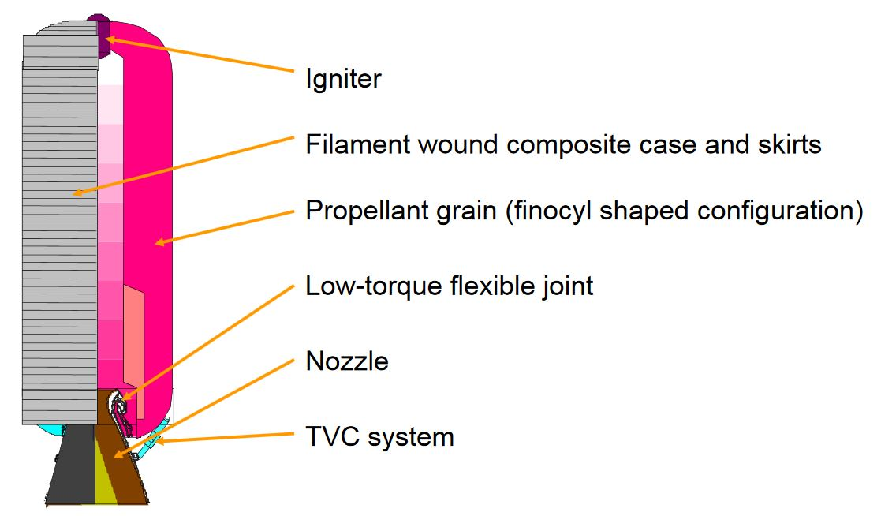

## Stakeholders expectations

### Fundamental need

The objective is first to understand the fundamental need justifying the development of the system studied. This can be done by answering the questions:

* Who does it serve? À qui le Produit rend-il service ?
* Who does it affect? Sur quoi le Produit agit-il ?
* "For what purpose" (what for?) « Dans quel but ? » (pour_quoi faire ?)

Thrust Vector Control System, fundamental need:

* Who does it serve? À qui le Produit rend-il service ? *The launcher flight control system*
* Who does it affect? Sur quoi le Produit agit-il ? *The system acts on the nozzle*
* "For what purpose" (what for?) « Dans quel but ? » (pour_quoi faire ?) *To control the angular velocities of the vehicle*

The Initial Function Statement is thus: The Thrust Vector Control (TVC) actuation system shall control the nozzle position in order to control the vehicle about the pitch and yaw axes. This statement describes a high-level function that the TVC actuation system must perform.

### Life cycle analysis

An analysis of the various life phases can help to determine which of them may have a significant influence on the solution finally developed. Examples of life phases:

|  |  |
| --- | --- |
| design | normal (primary) use |
| manufacturing | normal use (secondary) |
| metrology / integration testing | abnormal use (degraded mode) |
| packaging | maintenance |
| transportation | non-use |
| marketing | storage |
| assembly | repackaging |
| installation / implementation | updating |
| validation | recycling / destruction |

The main ones or Concept of Operations (ConOps) scenarios for our example are:

* Qualification tests
* The operating phase from take-off to separation of the propulsion stage
* Recovery and return to service

### System boundaries definition

It is also important to define the boundaries of the system under study. This will make it possible to define:

* what is imposed = the external elements with which the system will interact
* on what the designer can act = the system

Main interfaces of the TVC system:

* The system shall be self-sufficient in energy = no power interface
* The system shall communicate with the on-board computer via a data bus = data communication interfaces
* The system shall be mechanically connected to the nozzle and skirt of the launcher stage = structural interfaces

The context diagram of SysML language can help to give a graphical representation of the system and stakeholders.

## Requirements Definition

### Functional analysis

By analysing each life phase, the functions can be determinated. **Use case diagrams (SysML) or 'Diagramme pieuvre' (APTE) can** be helpful. These diagrams can be constructed by following the steps below:

* **Step 1:** Identify Actors. Determine who or what interacts with the system. These are your actors. They can be users, other systems, or external entities.
* **Step 2:** Identify Use Cases (oval). Identify the main functionalities or actions the system must perform. These are your use cases. Each use case should represent a specific piece of functionality.
* **Step 3:** Connect Actors and Use Cases. Draw lines (associations) between actors and the use cases they are involved in. This represents the interactions between actors and the system.
* **Step 4:** Add System Boundary. Draw a box around the actors and use cases to represent the system boundary. This defines the scope of your system.
* **Step 5:** Define Relationships. If certain use cases are related.

**Operating phase:**

*Use Case diagram:* 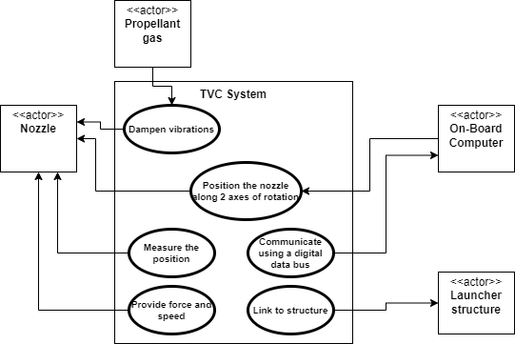

Functional analysis reveals a large number of functions, and it may be useful to rank them in the form of a functional tree. The FAST (Function Analysis Systems Technique) diagram advices to developp this functional tree thanks the questions 'Why?' and 'How?'. This can also help to identify or fully formulate the functions that would have escaped with the usual research methods research methods (spontaneous research in particular). The SySML requirement diagram can implement this tree.

*Requirements diagram:* 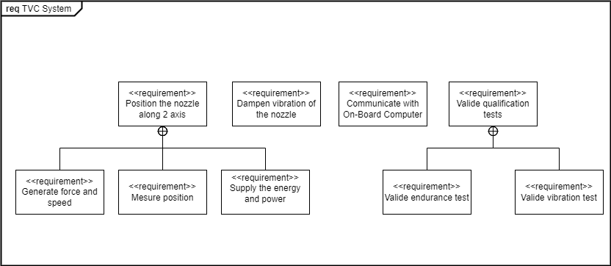

### Requirements expressions

The expression of requirements can take different forms. For example:

* According to the Nasa handbook [Nasa, 2017]: *The requirement is in the form “product ABC shall XYZ.” A requirement should state “The product shall” (do, perform, provide, weigh, or other verb) followed by a description of what should be done.*

Functional Requirements - What the “system” does  
Performance Requirements - How well the “system” executes the function  
Interface Requirements - An Interface Requirement is a requirement that specifies the ports for connecting systems and parts of a system.

* According to APTE method: *A function is made up of a verb or verbal group characterising the action, and complements representing the elements of the external environment affected by the function. The subject of the sentence does not appear, but it always refers to the product.*

| Function | Criteria | Level | Flexibility |
| --- | --- | --- | --- |
| FP1 Position the nozzle along 2 axis | Angle of rotation | +- 6° | F1 |
| FP1.1 Provide force and speed | Maximum speed | 10 °/s | F1 |
|  | Maximum torque | 100 kN.m | F1 |
| FP1.2 Provide energy and power | Evaluate the energy and power required for a typical mission profile | Nozzle angular deflection versus time data file | F1 |

### Logical definition

The objective is to define the architecture (organic and software) that will enable the requirements developed above to be met. Each component of this architecture must satisfy at least one requirement (otherwise it is of no use to the system) and each requirement must be satisfied by at least one system component. The 'Satisfy' link is used to represent this requirement/system component relationship in a SysML diagram.

*Architecture validation:* 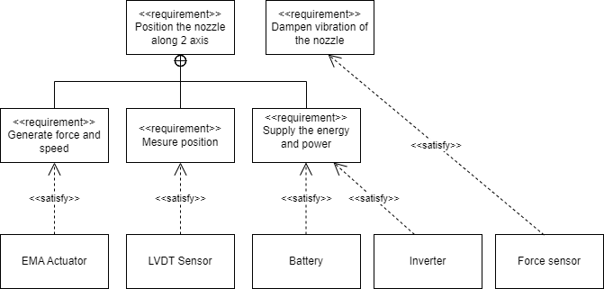

To meet a set of functional requirements, a multi-technology system is made up of components organised around two chains : the energy chain, the information chain

*IBD (Internal Block Diagram) of information processing and power transmission parts:*  
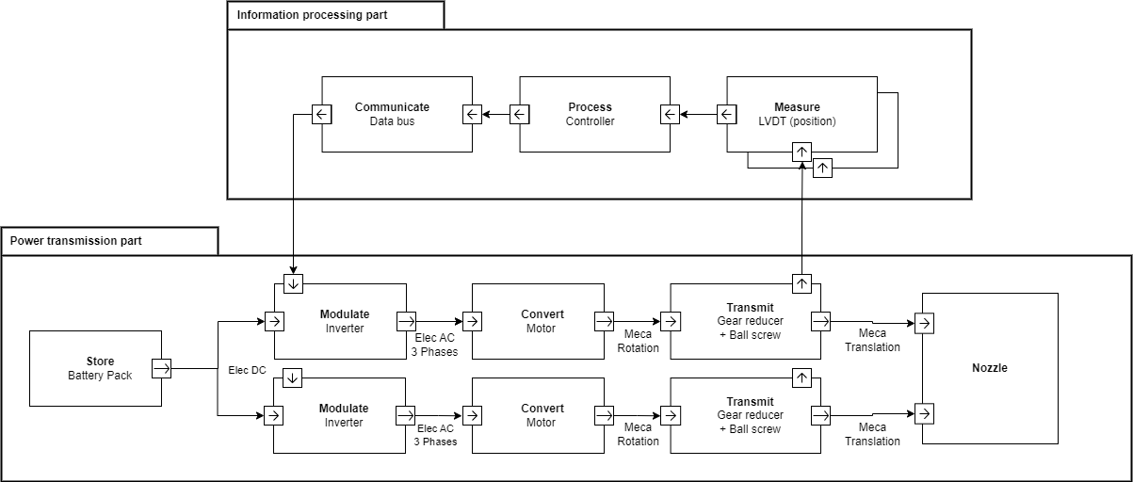

*Thrust Vector Control (TVC) actuation system:*

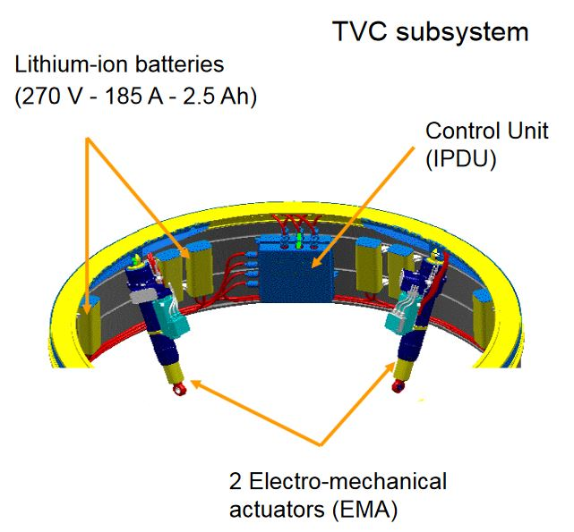

## Homework

* Follow the steps described here to define the requirements for a CubeSat battery with a thermal control such as this [one](https://gomspace.com/UserFiles/Subsystems/datasheet/gs-ds-nanopower-bp4_(DS_-_1013024_-_1_-_31)_-_1.pdf)

*Nanopower board of GOMspace* 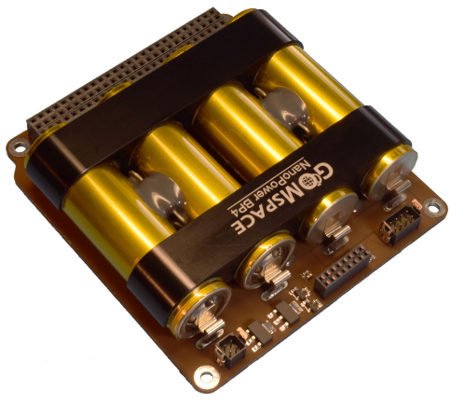

* Complete examples of a use case diagram, a function tree (specifying functions, criteria and requirement levels) and an Internal Block diagram (IBD) for the thermal control part.

**Note:** The SysML diagrams on this notebook (see [here](https://github.com/SizingLab/SystemsEngineeringIntroduction/tree/main/notebook/figures) .drawio files) were produced using the free Draw.io tool. The software can be installed on a [PC](https://www.drawio.com/blog/diagrams-offline) or used online. The SySML library must be [activated](https://www.drawio.com/blog/sysml-vs-uml) to be used.

## References

[Nasa, 2017] Hirshorn, S. R., Voss, L. D., & Bromley, L. K. (2017). Nasa systems engineering handbook (No. HQ-E-DAA-TN38707). [Link](https://www.nasa.gov/wp-content/uploads/2018/09/nasa_systems_engineering_handbook_0.pdf)

[Le Gallou] Le Gallou Y., Huguet, M., Ingénierie Systeme et langage SysML, notes de cours. [Link](http://michel-huguet.fr/wp-content/uploads/2019/08/IS_SysMl.pdf)

[Audry, 2010] Audry, M. F. (2010). La démarche d’analyse fonctionnelle. Académie de Versailles. [Link](https://sti.ac-versailles.fr/IMG/pdf/analyse_fonctionnelle_guide_pour_le_professeur-2.pdf)

[Huguet] Huguet, M., Analyse fonctionnelle, Chaines d'énergie et d'information, notes de cours. [Link](http://michel-huguet.fr/wp-content/uploads/2019/08/1A3-Analyse-fonctionnelle.pdf)

# Thermal Control System

## Thermal control technologies

To complement the conference, you can find an overview of cubesat's thermal control technologies in the book available [here](https://pressbooks-dev.oer.hawaii.edu/epet302/) in chapter 7.

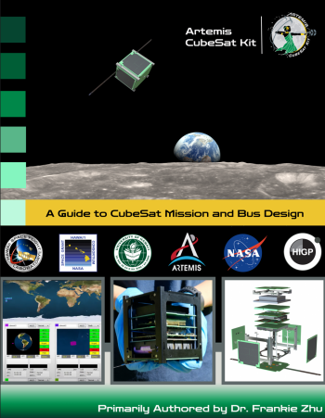

## Cubesat thermal model

The rest of the project requires a thermal model of the satellite to assess the heating requirements of the battery. The paper below:

Rossi, S., & Ivanov, A. (2013, September). Thermal model for cubesat: A simple and easy model from the Swisscube’s thermal flight data. In Proceedings of the International Astronautical Congress (Vol. 13, pp. 9919-9928). [Link](https://www.researchgate.net/publication/299535685_THERMAL_MODEL_FOR_CUBESAT_A_SIMPLE_AND_EASY_MODEL_FROM_THE_SWISSCUBE%27S_THERMAL_FLIGHT_DATA)

proposes a very simple 2-node model that can be used in the preliminary phase of a project.

## Homework

* Propose a simple battery thermal control architecture.
* Read the article in order to be able to carry out a thermal balance taking into account a nanosatellite and a subsystem such as a battery.

# Introduction to multiphysics modeling of sizing scenarios

The aim of this section is to illustrate how multiphysics modelling with localised parameters can be used to derive requirements from a system level, such as a rocket, to a sub-system level, such as a TVC actuation system. We will illustrate here how the maximum forces and speeds of a nozzle actuator can be obtained:

* using a Modelica model
* using a numerical simulation of the corresponding equations in Python

## Nozzle modeling

The nozzle is composed of:

* a flexible bearing or flexseal which links the nozzle to the launcher and enables rotational movement. The equivalent characteristics and parameters for this flexible bearing are:
  + a stiffness of 1.52E+04 Nm/deg.
  + a viscous damping of 1.74E+02 Nms/deg
* a rigid cone modeled here as:
  + an inertia of 1.40E+03 kg.m^2

*P80 Nozzle (from* [*ESA presentation*](http://www.ingaero.uniroma1.it/attachments/1609_VEGA%20%20sapienza%20small.pdf)*)*: 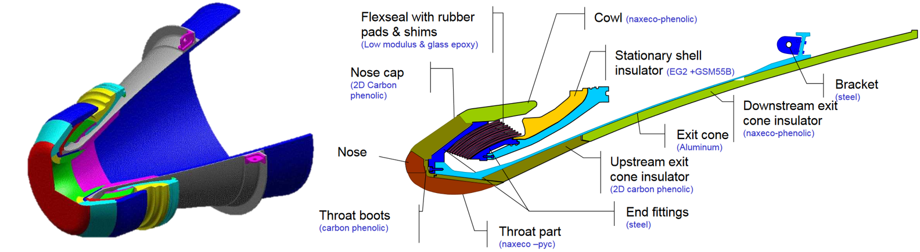

The EMA (Electro Mechanical Actuator) is between 2 points of the following drawing. The given values correspond to a nominal case. The lever arm for these nominal dimensions is 1.35 m at neutral position. The variation of lever arm with position order is assumed to be negligeable here due to the small nozzle deflection (+/- 5.7° max)

*Actuator implantation*:  
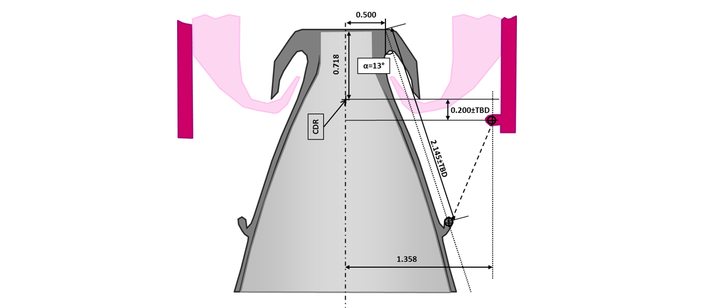

**Exercice**: Select the diagram made up of rotational inertia, torsional stiffness and viscous friction to represent the nozzle. Complete it to represent the EMA actuator, assumed here to be a source of force. 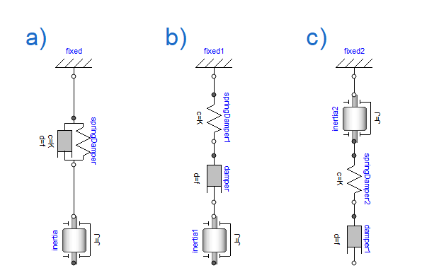 :::

## Sizing scenarios

The requirements at launcher level, particularly in terms of flight stability, can be used to generate typical displacement profiles at nozzle level. These profiles can be used on test benches to qualify the performance of the system produced.

*Angle order (°) function of time (s)*:  
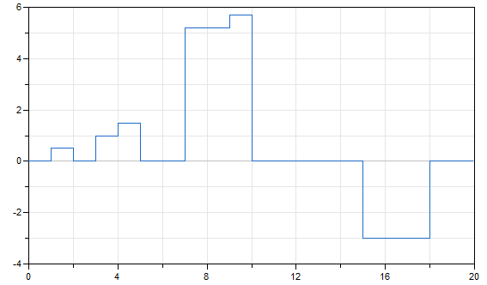

**Question:** What do you think of this profile?

**Question:** How do you generate a realistic nozzle angle profile from this requirement?

Simulations can produce: changes in position, speed and acceleration, as well as the forces to be applied. The scipy package can be used to calculate step responses to transfer functions.

Velocities and accelerations are easily obtained by adding derivatives to the transfer functions:

* position $\frac{1}{1+\frac{2ξp}{ω_{0}}+\frac{p^{2}}{ω_{0}^{2}}}$
* speed $\frac{p}{1+\frac{2ξp}{ω_{0}}+\frac{p^{2}}{ω_{0}^{2}}}$
* acceleration $\frac{p^{2}}{1+\frac{2ξp}{ω_{0}}+\frac{p^{2}}{ω_{0}^{2}}}$

For linear models that can be represented by transfer functions or state models, it is possible to use the function [scipy.signal.step](https://docs.scipy.org/doc/scipy/reference/generated/scipy.signal.step.html) to calculate the desired response.

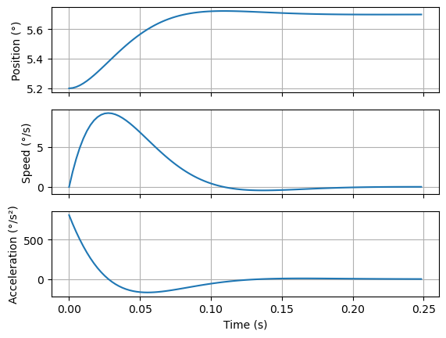

For potentially non-linear systems represented by a set of differential equations and algebraic equations, it is possible to use the function [scipy.integrate.odeint](https://apmonitor.com/pdc/index.php/Main/SolveDifferentialEquations) to numerically integrate the system model.

scipy.integrate.odeint requires three inputs:

y = odeint(model, y0, t)

**model**: Function name that returns derivative values at requested y and t values as dydt = model(y,t)

**y0**: Initial conditions of the differential states

**t**: Time points at which the solution should be reported. Additional internal points are often calculated to maintain accuracy of the solution but are not reported.

**Question:** Transform the previous transfert function $H\left(p\right)=\frac{θ\left(p\right)}{θ_{order}\left(p\right)}=\frac{1}{1+\frac{2ξp}{ω_{0}}+\frac{p^{2}}{ω_{0}^{2}}}$ representation into differential equations usable by scipy.integrate.odeint.

### 

It's now possible to calculate the force of the actuator which is requested to respect this mission profile.

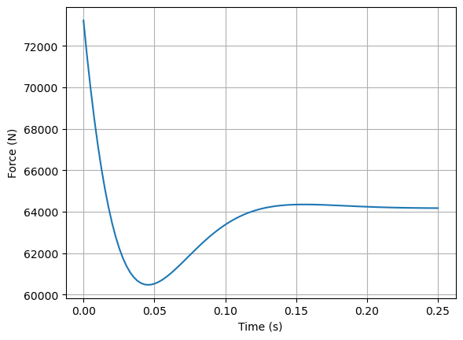

### Force speed diagram

This sizing scenarios can be represented on a force-speed diagram usefull for compenent selection.

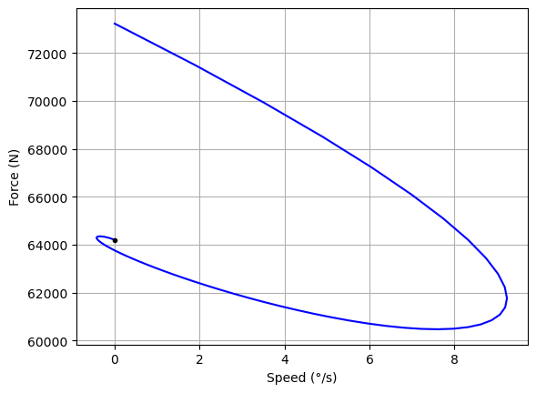

### Derived requirements

For the next sizing steps, the following derived requirements can be used:

* the nozzle max speed (step response)
* the max static torque (max deflexion)
* for max dynamic point (step response) : Max force with acceleration

In the nozzle frame (rotational movement):

Max nozzle rotational speed: 9.24 °/s  
Max static torque : 86640.00 N.m  
Max dynamic torque : 98860.13 N.m and max acceleration : 811.15 °/s²

For the linear actuator (translational movement):

Lever arm: 1.35 m  
Max linear speed: 0.22 m/s  
Max static force: 64177.78 N  
Max dynamic force: 73229.72 N and max acceleration: 11.57 m/s²

## Homework

Read the following article in order to developp a transient simulation of thermal response of a cubesat.

[Rossi, 2013] Rossi, S., & Ivanov, A. (2013, September). Thermal model for cubesat: A simple and easy model from the Swisscube’s thermal flight data. In Proceedings of the International Astronautical Congress (Vol. 13, pp. 9919-9928). [Link](https://www.researchgate.net/publication/299535685_THERMAL_MODEL_FOR_CUBESAT_A_SIMPLE_AND_EASY_MODEL_FROM_THE_SWISSCUBE%27S_THERMAL_FLIGHT_DATA)

## References

[Budinger, 2019] Budinger, M., Hazyuk, I., & Coïc, C. (2019). Multi-physics Modeling of Technological Systems. John Wiley & Sons.

# Control software development

This lecture will look at the information processing part of a mechatronic system in terms of control loops and digital implementation of controllers.

*Information processing part of a mechatronic system:* 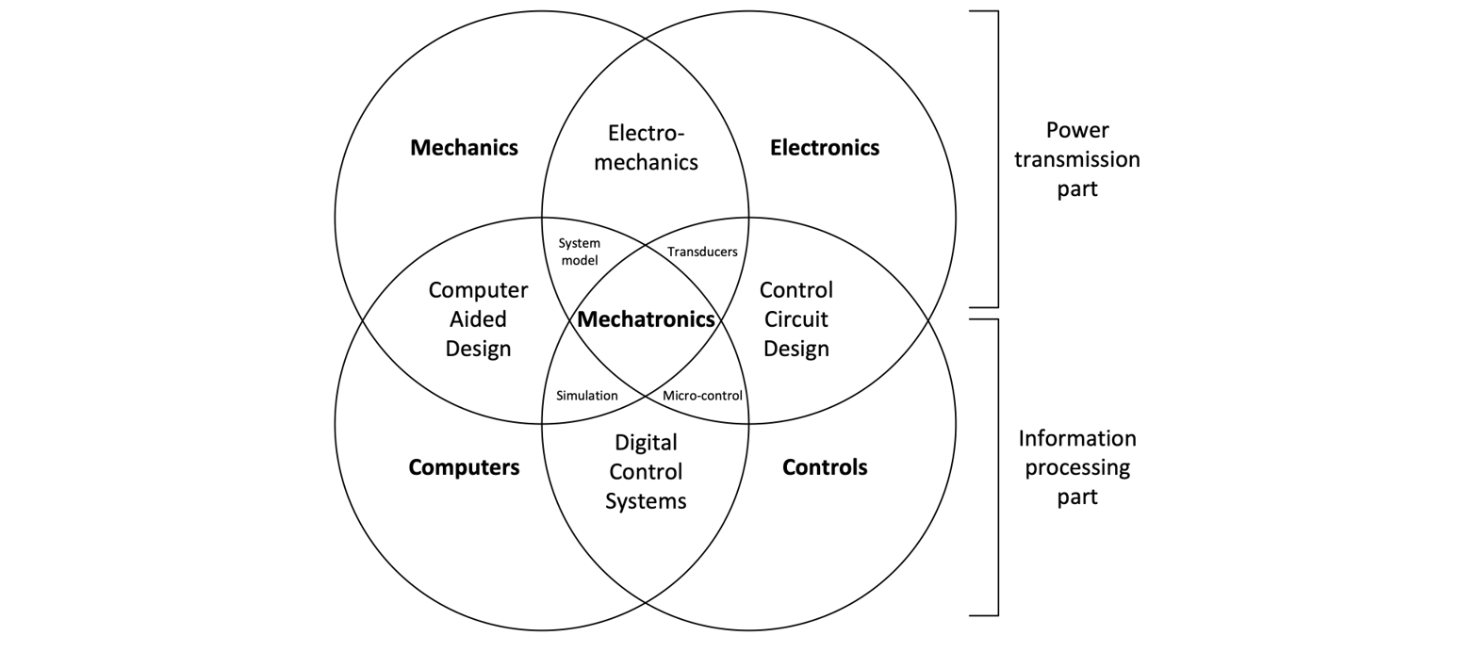

## Digital controller development cycle

Software components and digital controllers are becoming essential in the development of new automated systems. They offer a wide range of functions at low cost and are flexible in terms of use and maintenance. However, development times are potentially long with specific stages and test times to detect coding errors.

To maximise the benefits of the software and minimise the disadvantages of development, engineers have access to tools at the various stages of the V cycle:

* **MIL or Model In the Loop:** the controller principle is tested by simulation.
* **RCP or Rapid Control Prototyping:** a digital implementation of the controller is implemented in a powerful dedicated processor. The code is generated using specific tools. The physical system is real and can take the form of a reduced-scale model or part of the system.
* **SIL or Sofwtare In the Loop:** the controller software code is computer-tested on a simulated physical system.
* **HIL or Hardware In the Loop:** the software code is implemented in the product's digital controller. This software/controller assembly is tested electronically on a simulated physical system in an HIL digital target.

**Software V design cycle:**  
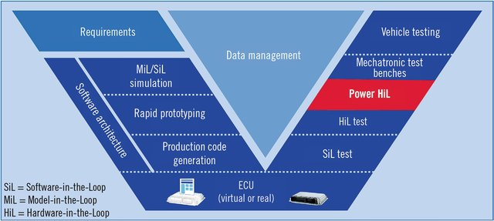

**Question:** Using the example of the control of a gyropode (segway), indicate which stage in the development of the digital controller each image below corresponds to.

**HIL quiz:**  
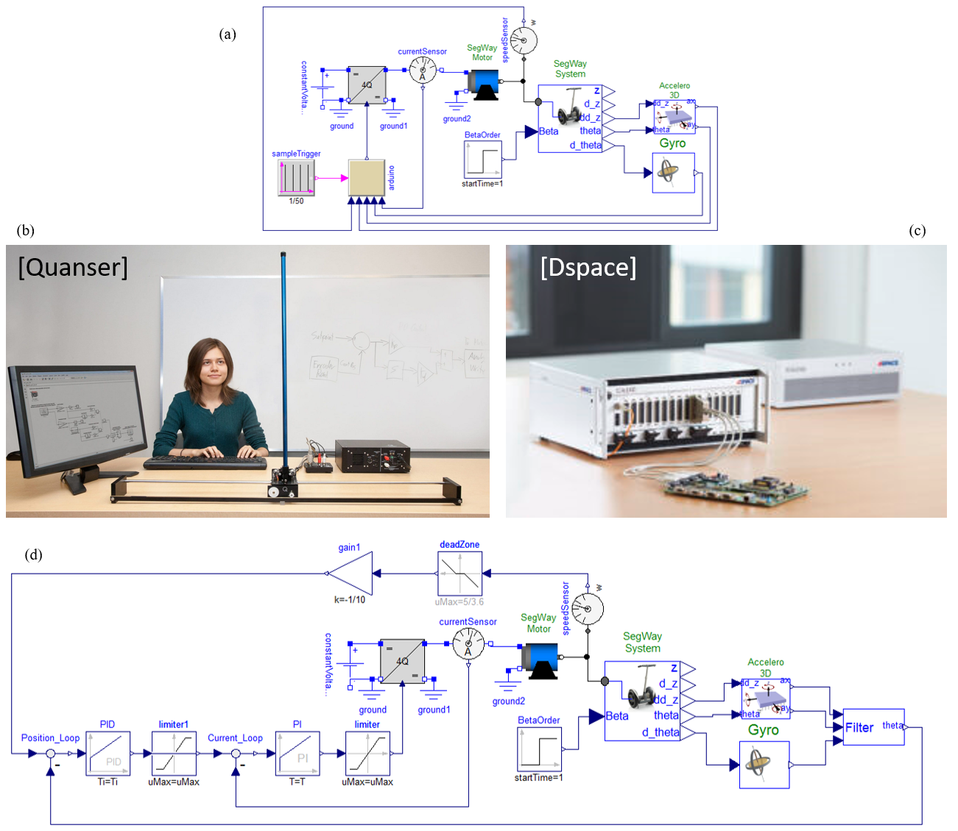

## Continuous controller

### Nested loops of a position control

We will illustrate the effects of digitisation on a launcher nozzle TVC controller. The TVC actuator considered here is an EMA (Electro-Mechanical) linear actuator. Its body is anchored on the booster frame while its rod is attached to the nozzle. In the normal mode, the TVC Actuator must perform a closed loop angular position control of the nozzle, following the demand of the flight control computer and rejecting the disturbances generated by the pulsed jet throught the nozzle. The TVC Actuator must also behave as a damper in order to limit the mechanical resonance effects.

**TVC actuator: position and tests**  
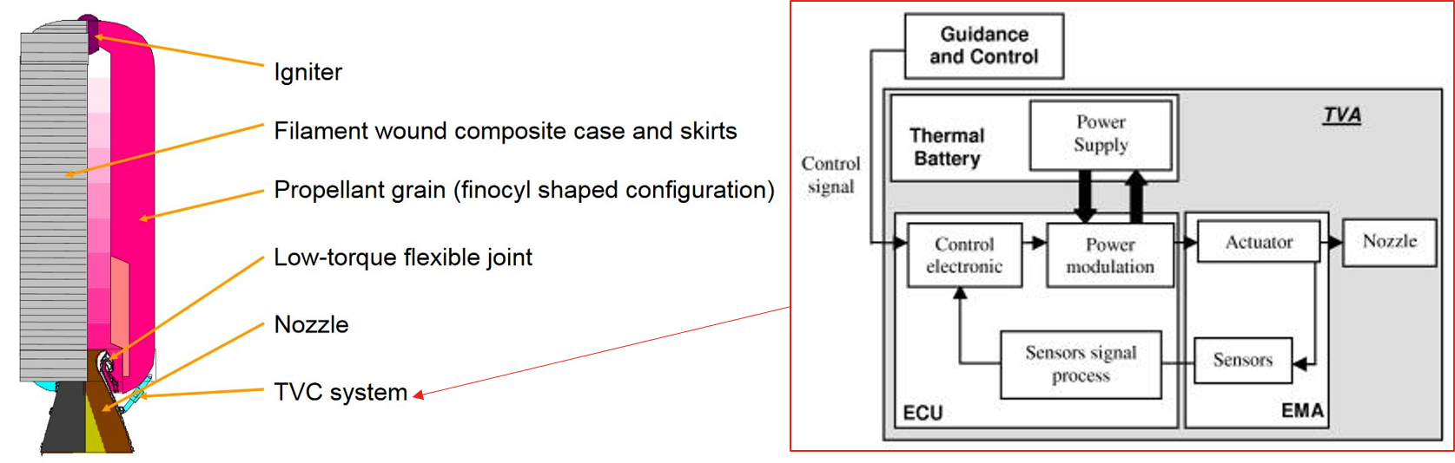 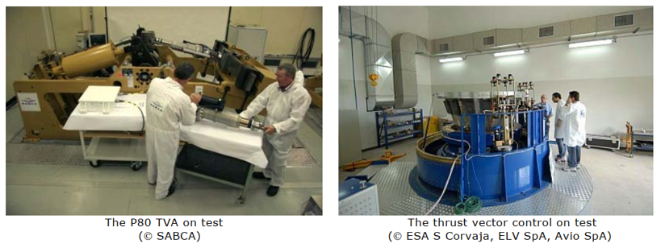

Each of the 2 actuators consists of a brushless permanent magnet synchronous motor that drives a roller screw through a gearbox. This way the rotational motion of the motor is transformed into a linear motion. A typical and generic architecture of small loop controller (big loop = launcher control) is represented below. Classical approach for the design of loop control foresees multiple nested loops (cascade):

* The inner **current or torque loop** is generally associated to a much larger bandwidth than the other loops.
* A **velocity loop**: for EMA, the motor angular position is measured using a resolver and derived to obtain a velocity feedback. A force sensor is added to drive the actuator in order to reduce the transient force and to damp oscillations.
* A external **position loop**: technical constraints impose to have a feedback on actuator position rather than nozzle position itself (which is the controlled parameter). LVDT sensor is generally used to measure the length variation of the actuator.

**EMA actuator:**  
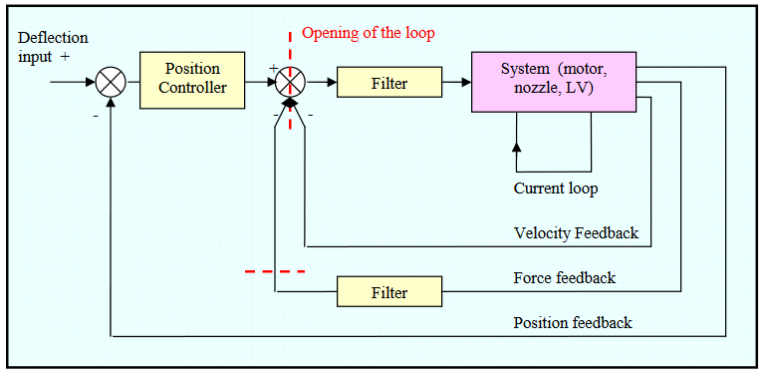 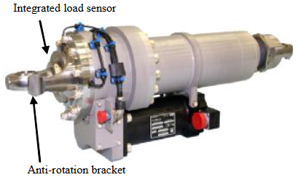

**Question:** Explain in simplified terms how force feedback can be used to introduce damping.

### 

### Speed loop of an EMA

We will focus here on the speed loop. We will represent the mechanical assembly nozzle / actuator by the diagram a) below with:

* the mass/spring/viscous friction assembly for the nozzle
* the rack-and-pinion assembly representing the screw/nut system and the EMA motor

*Mechanical models:* 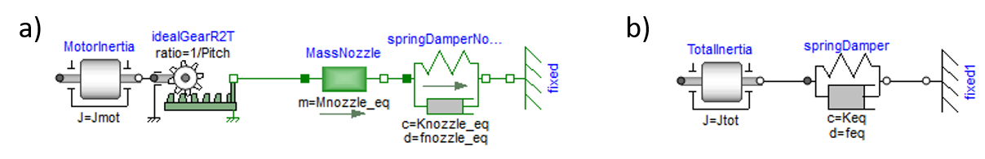

**Exercice:** Explain how to represent the previous model a) by the equivalent model in rotation b). Determine the transfer function relating torque to motor speed under these conditions.

Equivalent parameters :

Transfer function :

The Bode diagram of the transfer function can be displayed using the [python-control library](https://python-control.readthedocs.io/en/0.9.4/).

import control as ct  
  
# Parameters  
pitch=1.25e-3 # [m/rad] pitch  
Jmot=3e-3 # [kg] motor inertia  
fn=5475 # [N/(m/s)] nozzle equivalent viscous friction   
Mn=770 # [kg] Nozzle equivalent mass  
Kn=478000 # [N/m] Nozzle equivalent stiffness  
  
# Rotational equivalent parameters  
Jeq=Mn*pitch**2  
Keq=Kn*pitch**2  
feq=fn*pitch**2  
Jtot=Jmot+Jeq  
  
# Transfer function  
sys_meca = ct.tf([1, 0], [Jtot, feq, Keq])  
sys_iLoop = ct.tf(1, [1/(2*3.14*500)**2, 2*0.7/(2*3.14*500), 1])  
sys_open=sys_iLoop*sys_meca  
  
# Bode diagram  
mag, phase, omega= ct.bode_plot(sys_open, plot=True, Hz=True, initial_phase=90,margins=True)

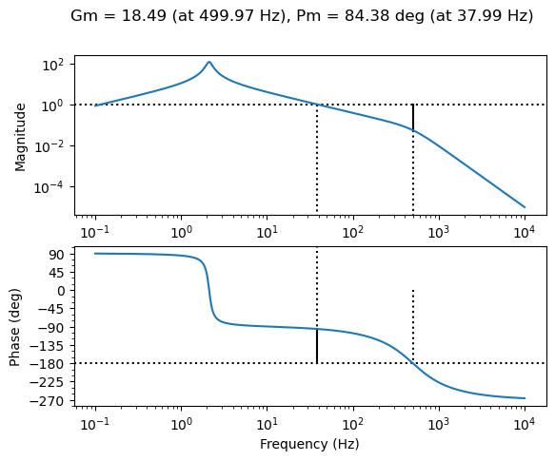

**Exercice:** Propose a corrector with zero static error and a closed bandwidth of 40 Hz. Make sure you have a minimum phase margin of 45° and a minimum gain margin of 10 dB.

# PI controller  
Kp=1.05  
tau_i=1/(5*2*3.14)  
PI=ct.tf([Kp*tau_i, Kp], [tau_i, 0])  
  
# Open loop  
PISys=PI*sys_open  
  
# Bode diagram  
mag, phase, omega= ct.bode_plot(PISys, plot=True, Hz=True, margins=True, grid=True, initial_phase=0)  
  
print("PI controller:")  
print("Kp = %.2f"% Kp)  
print("Tau = %.2e"% tau_i)  
print("Ki = Kp/Tau_i = %.2e"% (Kp/tau_i))

PI controller:  
Kp = 1.05  
Tau = 3.18e-02  
Ki = Kp/Tau_i = 3.30e+01

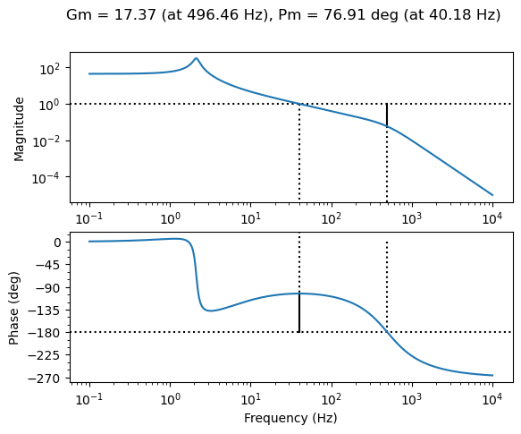

## Digitizing a controller and the effect of sampling frequencies

### Delay in digital controller

The previous synthesis of the corrector was done in the continuous domain. However, its implementation will most often be digital rather than analogue. Digital control (using a µC microcontroller or a DSP signal processor) offers the following advantages [Ellis, 2012]:

* lower noise sensitivity, better accuracy, less performance drift
* ease of changing gains or parameters.

However, digital control has one main weakness: the introduction of delay in the control loop. These delays generate phase shifts that can lead to instability or limit the gains and ultimately the bandwidth of the system.

Digital systems operate in discrete time steps. At regular intervals, the controller reads the feedback and command information, executes control algorithms, and outputs control orders. Between intervals, the output is held at a fixed level. This is what gives digital control waveforms their characteristic "stair step" appearance. The figure below shows a sinusoidal waveform at its sampled equivalent. The effect of sampling with a period $T_{s}$ can be approximated as a pure delay of $T_{s}/2$.

*Sampling effects:* 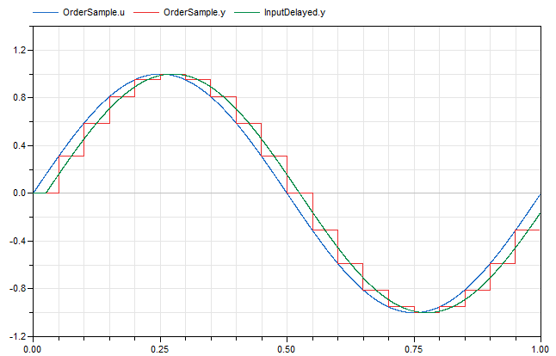

**Exercice:** Characterise the effect of sampling on gain and phase. Perform the numerical applications for a sampling period of 8 ms (125 Hz).

**Note:** Delays can be approximated by Padé transfer functions with python implementation in the [control package](https://python-control.readthedocs.io/en/latest/generated/control.pade.html). A first-order Padé approximation of a T time delay is $e^{-Tp}=\frac{1-\frac{T}{2}p}{1+\frac{T}{2}p}$

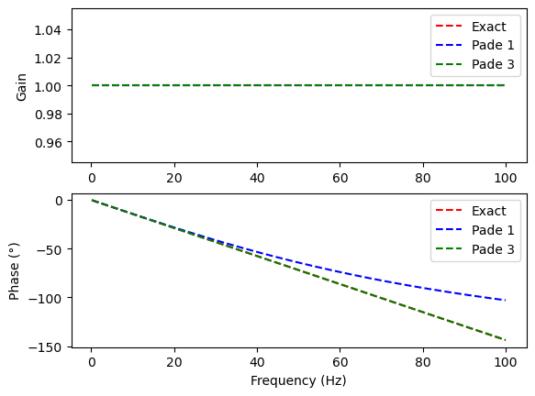

**Note:** Delays can come from a variety of sources:

* Sample-and-hold: 0.5T
* Calculation delay: 0.1T-0.9T
* Velocity estimation: 0.5T (motion systems)

Their effects are added together to produce a total delay. The anti-aliasing filter can also create phase shifts that need to be taken into account. The sampling frequency must be chosen carefully with all these effects.

**Exercice:** Evaluate the effect of sampling at a period of 8 ms on the previous corrector. Suggest a sampling frequency compatible with the desired performance.

Gain margins and phase margins have fallen sharply compared with the continuous configuration. The sampling frequency must therefore be increased. Assuming a accepted phase variation of 5° for the unity gain angular frequency $ω_{u}$.

The following figure shows the effects of sampling on stability trough Modelica simulations. It can be seen that (without taking into account delays due to speed calculation or calculation times) a sampling time of 1 ms gives a behaviour identical to that of the continuous controller. However, with a sampling time of 5 ms, the system is much less stable: the loss of phase margin is far too great in this case.

*Sampling effect:* 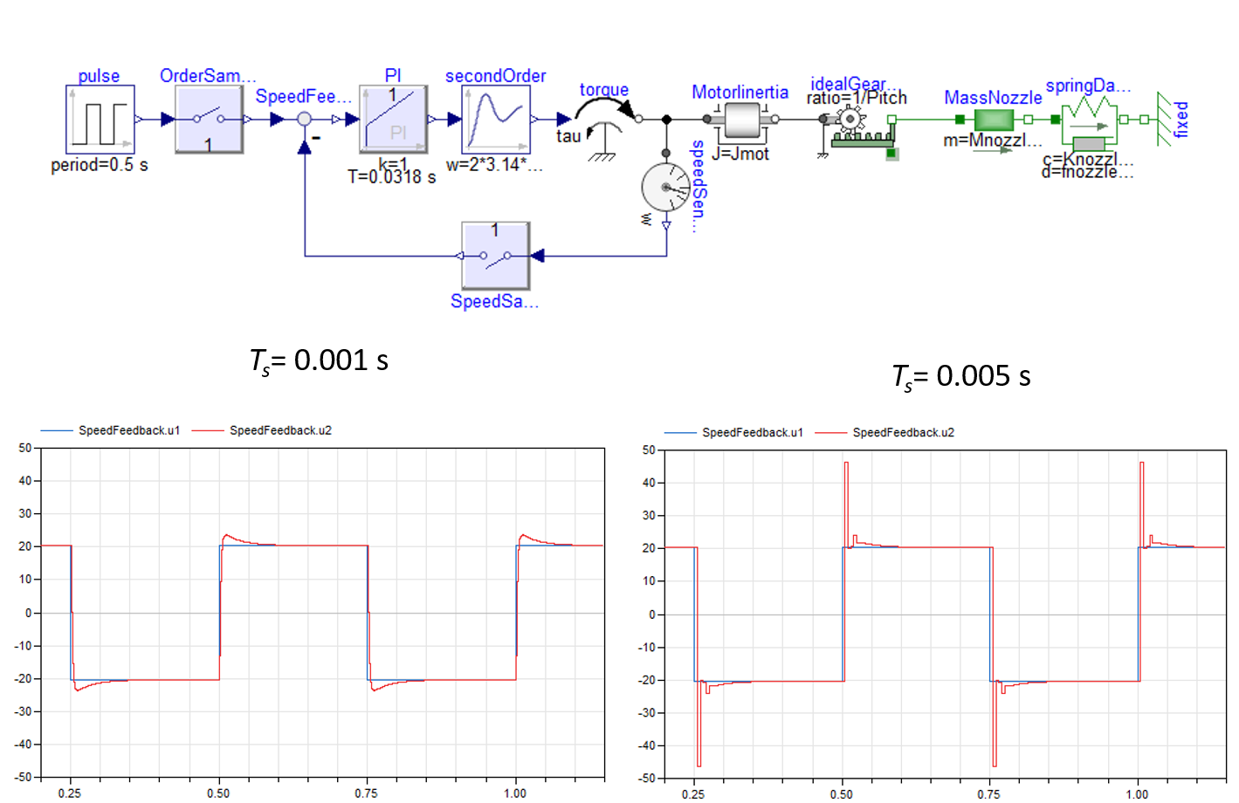

### Discrete-time PID Controller Implementation

Since computers and microcontrollers cannot deal with continuous time, the control law has to be discretized. We'll use the parrallel form of a PID controller: $$C\left(p\right)=\frac{O\left(p\right)}{E\left(p\right)}=K_{p}+\frac{K_{i}}{p}+K_{d}p$$

*PID schema block:*  
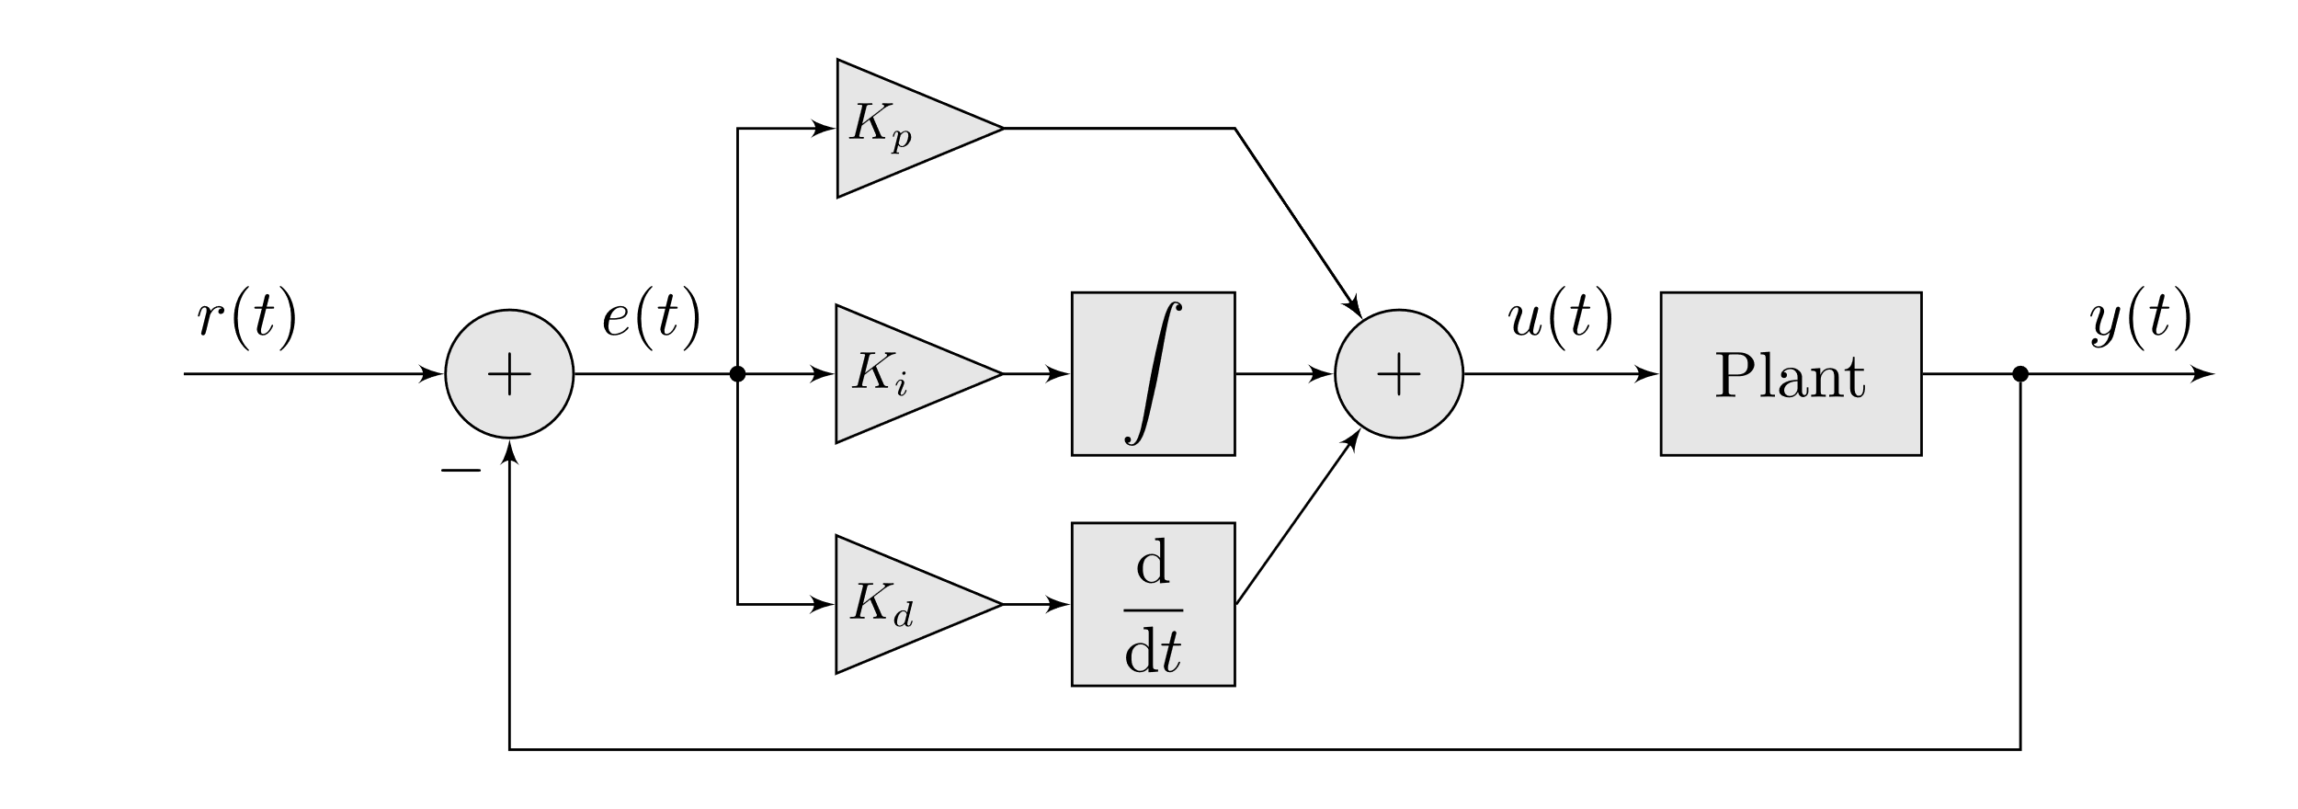

**Note:** Other forms of PID controller are:

* serial form $C\left(p\right)=K_{p}\left(1+\frac{1}{τ_{i}p}\right)\left(1+τ_{s}p\right)$
* standard form $C\left(p\right)=K_{p}\left(1+\frac{1}{τ_{i}p}+τ_{s}p\right)$

The time expression of this corrector is as follows: $$o\left(t\right)=K_{p}.e\left(t\right)+K_{i}∫e\left(t\right)dt+K_{d}\frac{de\left(t\right)}{dt}$$ 
with the error: $e\left(t\right)=SetPoint\left(t\right)-Input\left(t\right)$

One of simplest methods available is to approximate this continuous-time ordinary differential equation by discrete-time difference equations or recurrence relations.

A first approach with parrallel form of the PID controller is:

* for proportionnal term: $K_{p}.e\left(t\right)≈K_{p}.e_{k}$ where $e_{k}=e\left(k.T_{s}\right)$
* for integration term: $K_{i}∫e\left(t\right)dt≈K_{i}\sum_{j=0}^{k}{e_{j}}T_{s}=K_{i}.I_{k}$ where $I_{k}=I_{k}-1+e_{k}T_{s}$
* for derivation term: $K_{d}\frac{de\left(t\right)}{dt}≈K_{d}\frac{e_{k}-e_{k-1}}{T_{s}}$  
  with the time step or sampling interval $T_{s}$.

The PID output in response to measurements is thus: $$I_{k}=I_{k-1}+e_{k}T_{s} \\ O_{k}=K_{p}e_{k}+K_{i}I_{k}+K_{d}\frac{e_{k}-e_{k-1}}{T_{s}}$$

Another more general approach applicable to any transfer function and therefore any form of corrector is as follows:

* Write the transfer function in numerator/denominator form $$C\left(p\right)=\frac{O\left(p\right)}{E\left(p\right)}=\frac{K_{p}p+K_{i}+K_{d}p^{2}}{p}$$
* Reformulate in the form of a differential equation $$pO\left(p\right)=\left(K_{p}p+K_{i}+K_{d}p^{2}\right)E\left(p\right) \\ \dot{o}\left(t\right)=K_{i}e\left(t\right)+K_{p}\dot{e}\left(t\right)+K_{d}\ddot{e}\left(t\right)$$
* Discretize in the form of a recurrence equation $$\frac{o_{k}-o_{k-1}}{T_{q}}=K_{i}e_{k}+K_{p}\frac{e_{k}-e_{k-1}}{T_{s}}+K_{d}\frac{e_{k}+e_{k-2}-2e_{k-1}}{T_{s}^{2}} \\ o_{k}=o_{k-1}+K_{i}e_{k}T_{s}+K_{p}\left(e_{k}-e_{k-1}\right)+\frac{K_{d}}{T_{s}}\left(e_{k}+e_{k-2}-2e_{k-1}\right)$$

with $$f_{k}=f\left(kT_{s}\right) \\ \dot{f}\left(t\right)≈\frac{f\left(t\right)-f\left(t-T_{s}\right)}{T_{s}} \\ \ddot{f}\left(t\right)≈\frac{f\left(t\right)+f\left(t-2T_{s}\right)-2f\left(t-T_{s}\right)}{T_{s}^{2}}$$

**Note:**

* More advanced transformation or discretization method are [avalaible](https://tttapa.github.io/Pages/Arduino/Control-Theory/Motor-Fader/PID-Controllers.html).
* More advanced PID controller forms can be find [here](http://brettbeauregard.com/blog/2011/04/improving-the-beginners-pid-introduction/)

The following figure shows the effects of the digital implementation of the controller. Overall, the digital controller makes it possible to recover the behaviour of the continuous controller:

$$C\left(p\right)=\frac{O\left(p\right)}{E\left(p\right)}=K_{p}+\frac{K_{i}}{p}$$

using a simple recursive equation:

$$o_{k}=o_{k-1}+K_{i}e_{k}T_{s}+K_{p}\left(e_{k}-e_{k-1}\right)$$

*Digital controller:* 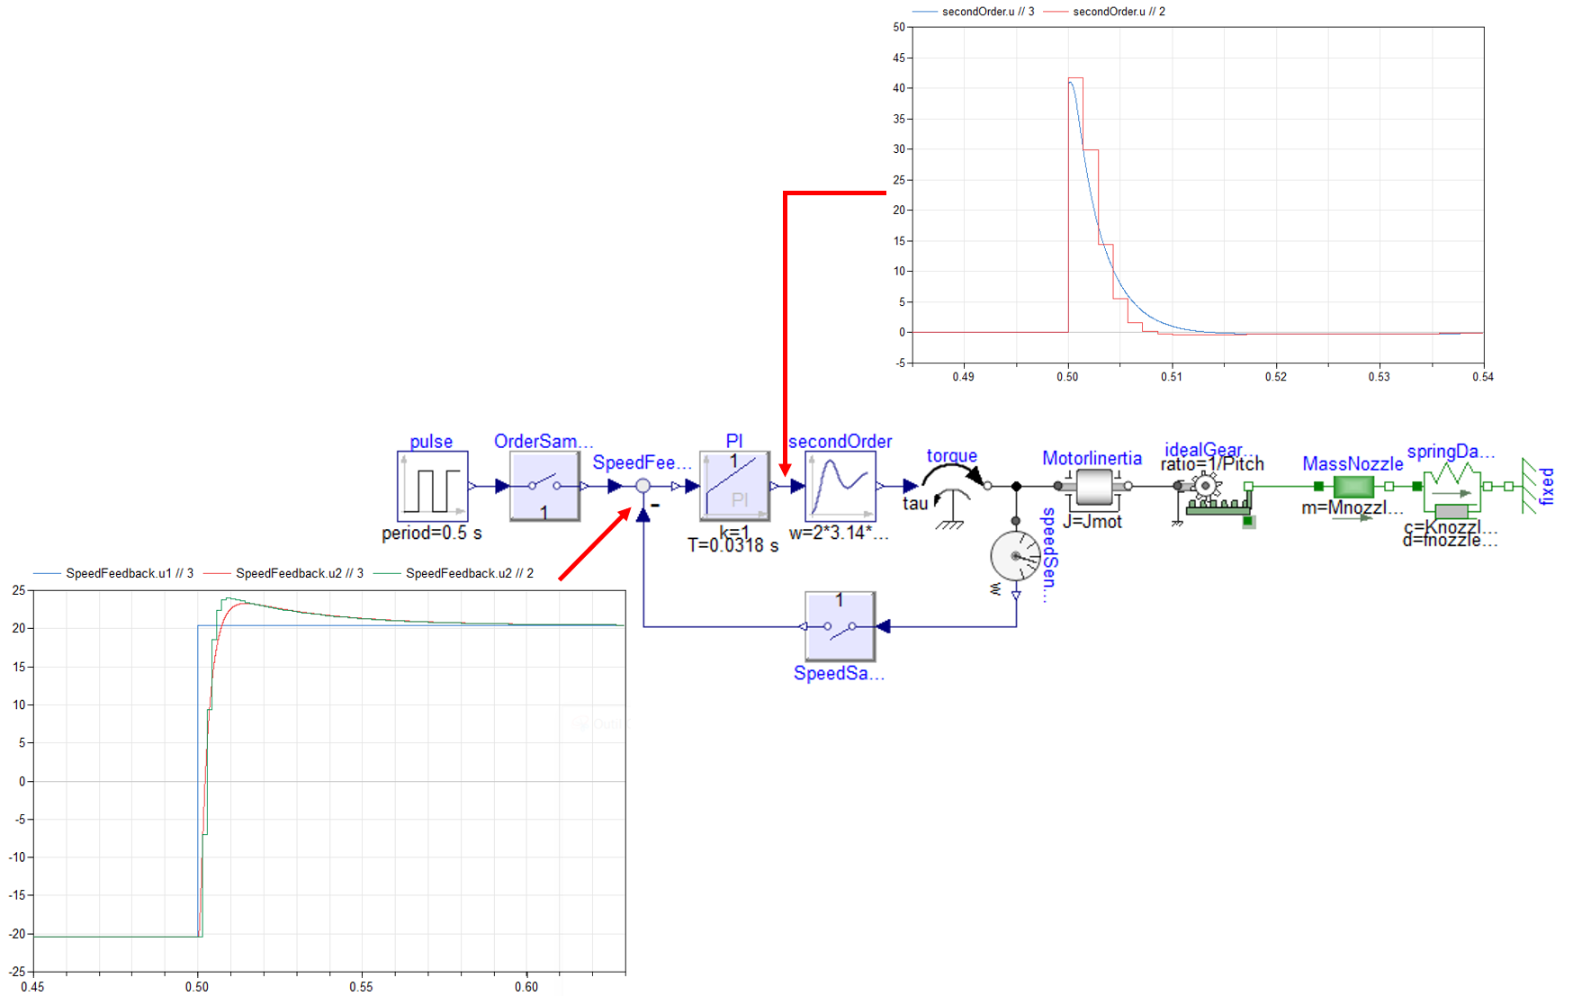

## Homework

Install the [Legacy Arduino IDE (1.8.X)](https://docs.arduino.cc/software/ide/#ide-v1) + the [Anaconda environment](https://www.anaconda.com/download) on your PC

Read this introduction to [C code on Arduino](https://catsr.vse.gmu.edu/SYST460/Intro%20to%20Arduino%20Programming.pdf).

## References

[Mihalič, 2022 ] Mihalič, F., Truntič, M., & Hren, A. (2022). Hardware-in-the-loop simulations: A historical overview of engineering challenges. Electronics, 11(15), 2462. [Link](https://www.researchgate.net/publication/362572593_Hardware-in-the-Loop_Simulations_A_Historical_Overview_of_Engineering_Challenges)

[Vanthuyne, 2009 ] Vanthuyne, T. (2009, September). An electrical thrust vector control system for the VEGA launcher. In Proceedings of the 13th European Space Mechanisms and Tribology Symposium (Vol. 670). [Link](http://esmats.eu/esmatspapers/pastpapers/pdfs/2009/vanthuyne.pdf)

[Carpentier, 2011 ] Carpentier, B., Puel, F., Cros, C., Pin, B., Gerbe, L., & Solide, S. S. P. (2011). Stability analysis using a coupled model of TVC actuator control loop and structural dynamics of a Launch Vehicle. In 4th European Conference For Aerospace Sciences (EUCASS).

[Ellis, 2012] Ellis, G. (2012). Control system design guide: using your computer to understand and diagnose feedback controllers. Butterworth-Heinemann.